**Hello World RESTful Web Service**

**Objective:**

Create a simple Spring Boot REST API that returns the message "Hello World!!" when accessed through a web browser or Postman.

**Steps:**

1. **Project Setup**
   * Created a Maven project using Spring Initializr
   * Group: org.example
   * Artifact: spring-rest
   * Dependencies: Spring Web, Spring Boot DevTools

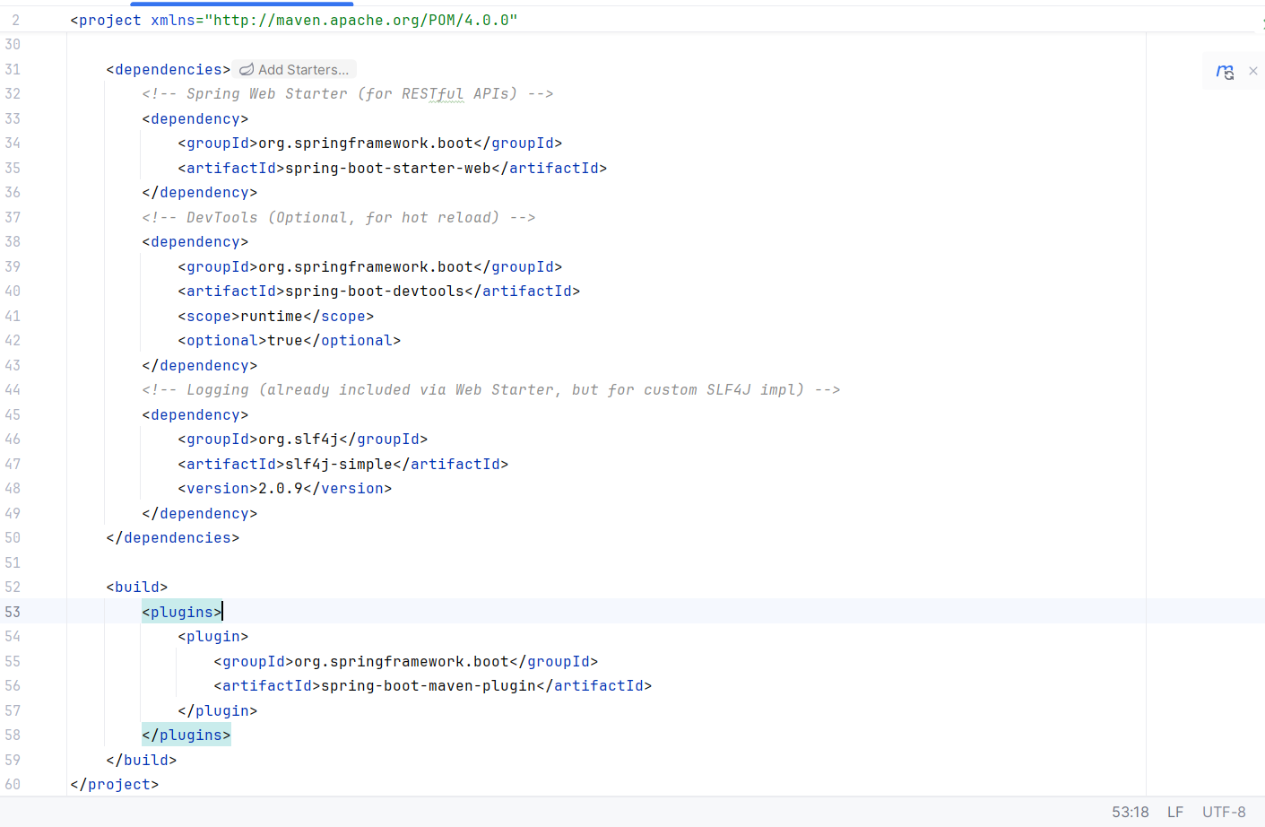

1. **Main Class**Created SpringRestApplication.java as the entry point

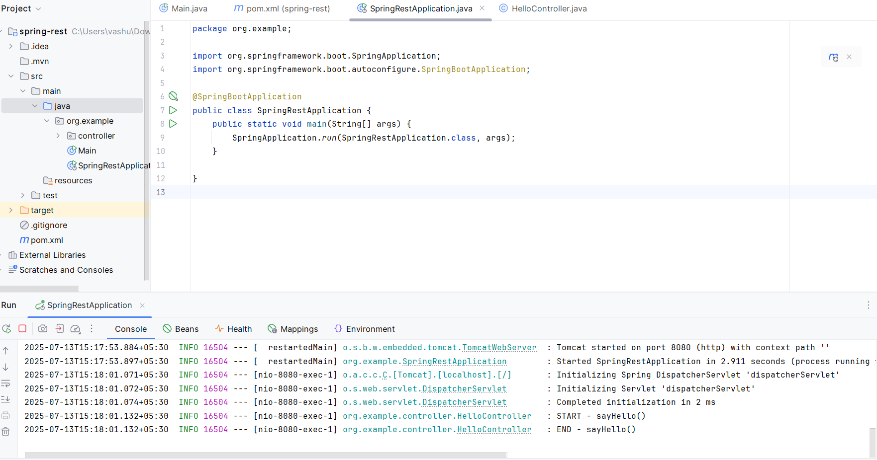

1. **Controller Class**  
   Created HelloController.java under org.example.controller

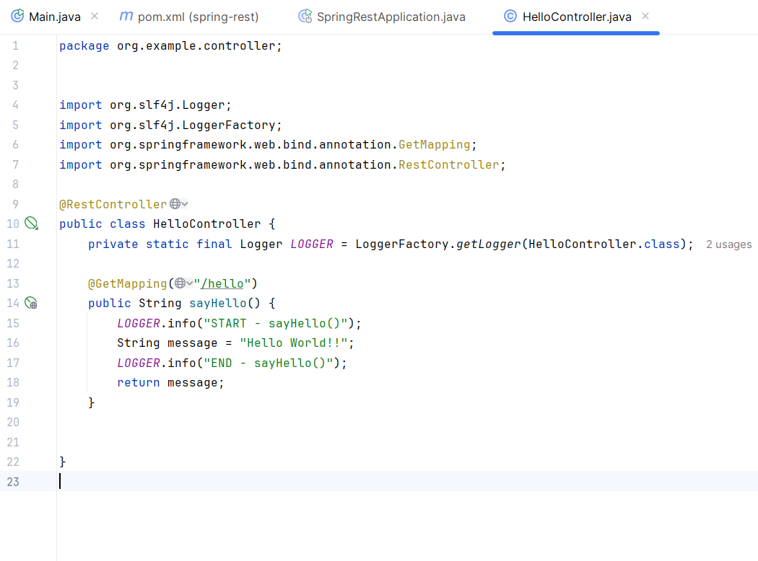

1. **Port Configuration**

* Used default port 8080
* Tested API using: http://localhost:8080/hello

1. **Testing & Output**

* Output in browser/Postman: Hello World!!
* Console logs showed:

